Molesey Amateur Regatta
www.moleseyregatta.org.uk

Race or Cheer from the Riverbank in this Summer Season Tradition
Weekend 15-2016 July
Riverside at Hurst Park, West Molesey

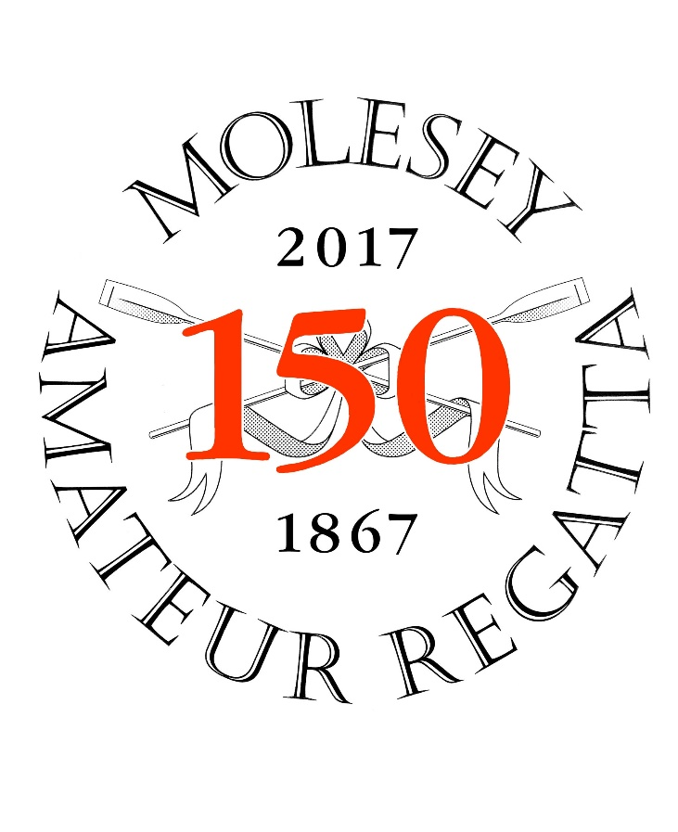
For 150 years Molesey Amateur Regatta has been one of the highlights of the summer regatta season for both the rowing and local community. Once again it will be returning to the banks of the River Thames just up from Hampton Court for another weekend of racing, picnics, and on the Saturday evening, live reggae and blues music.

Expect to find over 300 crews battling it out over the weekend with the Master, Senior and Explorer crews on Saturday and the Junior crews on Sunday. Full details are on the Molesey Amateur Regatta website.

Spectators are well catered for with an all day barbecue and marquees serving traditional afternoon teas, Pimms, local ales and much more. Several local craft shops have exotic and unusual articles for sale. A sit-down lunch is also available on Saturday at £35 per head for an all-day table.

Entrance is free and there is a car park off Ferry Road (£4 which includes a programme). Spread out a picnic and enjoy a full day of racing followed by live music on Saturday evening when the inspirational JAMSIDE UP group take over with their catching and inspirational music.

Racing commences early and runs continuously throughout both days with a break for lunch. The sheltered course takes around 3 to 4 minutes to complete and is 850m on Saturday and 500m on Sunday. The course starts opposite Aquarius Sailing Club (10 minutes walk up the towpath) and finishes just past the end of Platts Eyot.

Support this summer event and become a ‘Friend of the Molesey Regatta’ for an annual contribution of £20 and receive: free parking, programme, sheltered ‘Friends’ area in the marquee, and 2 vouchers for a drink or cream tea.

Address: Hurst Riverside (between Sadlers Ride and Ferry Road), West Molesey. KT8 1TJ
Information on race entry and the history of the regatta: www.moleseyregatta.org.uk

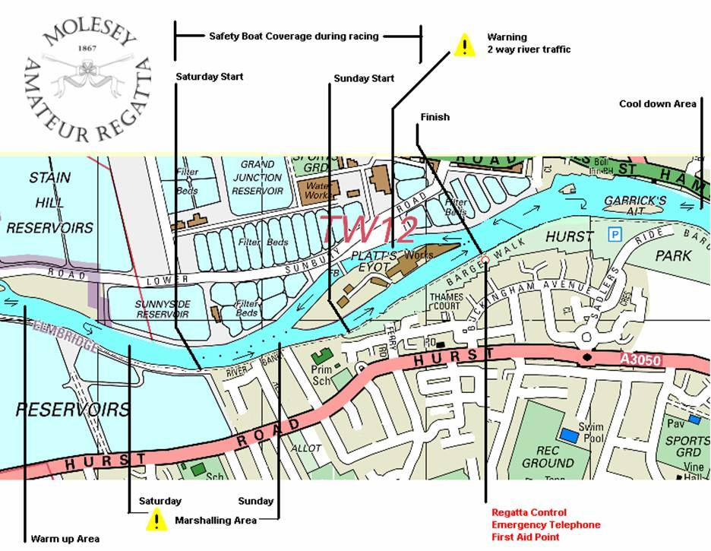

General information – tbates8888@aol.com 07951 638516
Publicity and Music – fe123wood@hotmail.com 07850 270002
Lunch Bookings - graeme.thompson@me.com 07973 177107
Friends - ggb-post@hotmail.co.uk 07787 515091

